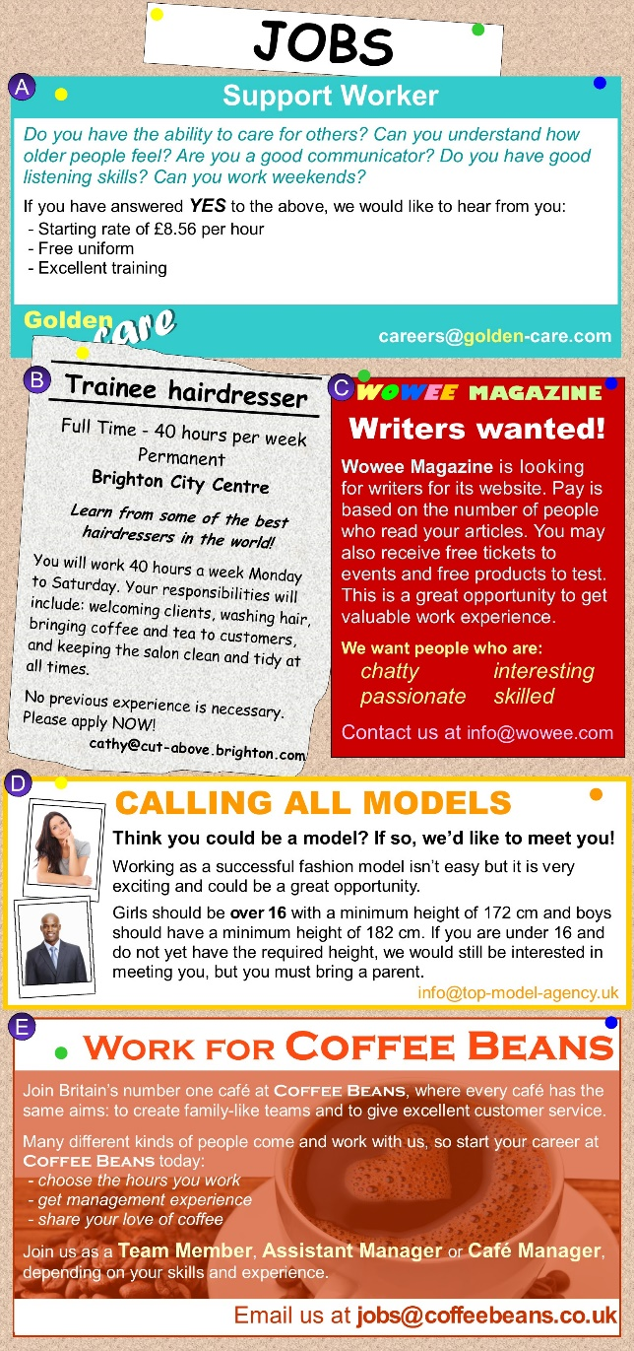
Wochenplan:
- Vocab. p. 264 meet - run
- Vocab. p. 221
- Do at least one activity on the irregular verbs you have revised so far with a partner. Ideas:
  - Make a memory game (card 1 has infinitve + second form, card 2 has third form and translation) and play it.
  - Make a test for each other and solve it.
  - Act the verbs out and have your partner guess them, then give all forms and the translation.
After class:
- Look at the instructions for writing cover letters in your book on p. 177.
- Use your CV to write a cover letter applying to one of the job advertisements on pp. 56-57.
  - Write about 160 words (140-200).
  - Put addresses and personal information at the top.
  - Structure your letter according to the example on p. 177.
  - Use adjectives and personal skills from your VC to describe yourself and explain why are best suited for this job.
  - Have someone read it and bring your CV to our next class.
Level 2:
Write a cover letter for one of the job advertisements to the right. Have somebody read it and give you feedback.

