Englischunterricht 6a

Das present perfect

- Schau dir nochmal die Erklärung im Buch auf Seite 164 an.

- Bearbeite folgende Aufgaben im Buch auf Seite 32/33.

G: Nr. 6, 7a
M: Nr. 6, 7 a und b, 9a
E: Nr. 6, 7 a und b, 9 a und b

- Lies den Text im Buch auf Seite 34. Schau dir dann den Kasten oben auf Seite 36 an, bearbeite anschließend Nr. 7. (zusätzliche Hilfe auf Seite 165)

- Kontrolliere und verbessere deine Aufgaben mit der Lösung.

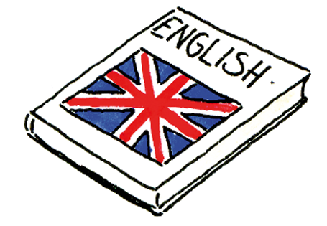

Lösungen
- SB 32/6 1.Jay has talked to Jamila about the interview. Jay has texted David. Jay has helped Dad with the shopping. Jay has tidied his bedroom. 2. Jay and Dave have finished the list of questions. Jay and Dave have looked at Jamila’s website. Jay and Dave have watched one of Jamila’s movies on DVD.

- SB 32/7 a) 1. Dave: Sorry, I have already seen that film. 2. Olivia: I have just bought new shoes so I have no money now. 3. Holly: I have just fed the guinea pigs. I want to watch TV now. 4. Jay’s dad: Jay isn’t here. He has just gone to the swimming pool. 5. Irina: I don’t want to go. I have just heard it’s an awful movie. 6. Jamie: I have already tidied my room. Can I come to the cinema?
- b) Come on, Luke! I have done the washing up, Jamie has taken the rubbish out and Irina has cleared the table, but no one has taken the bottles to the bottle bank. Can you do that for us before you go to the cinema? SB 33/8 Musterlösung: 1. A: Would you like to play football with me? B: Sorry I can’t! I haven’t tidied my room yet. Why don’t you ask Julia? A: I’ve just asked her. She hasn’t fed her pet yet. 2. Would you like to eat a pizza with me? … 3. Would you like to go to the cinema with me? …

- SB 33/9 a) 1.Luke has just phoned a friend. 2. They haven’t bought an ice cream yet. 3. Luke hasn’t cleaned his shoes yet. / Luke has just played football. 4. Dave hasn’t sent his e-mail yet. /Dave has just written an e-mail. 5. Olivia hasn’t finished her eaaaxercise yet. /Olivia has just started an exercise. 6. Holly and Olivia have already watched the movie.
b) Musterlösung: Irina and Jamie have (already) laid the table. Mr Elliot has (just) made dinner. The Elliots haven’t eaten (yet). Luke hasn’t come home (yet).

- SB 36/7 1. Have you finished your new film yet? 2. How many films have you made? 3. Have you made a film in London yet? 4. Which countries have you visited? 5. Have you seen Todd Driscoll’s new film yet? 6. Which directors have you worked with?

